Segen Tirfe
STAT 100
Section #: 0151
MINITAB Assignment 1
1. (10 points) Open the Restaurant_Tips data file. You will create a pie chart for a variable and answer questions related to the distribution of the variable.
a. Generate a pie chart to display the distribution of the Server variable. This variable indicates the name of the server for the table of customers served at the restaurant. Paste your pie chart into the document you upload for this assignment. The pie chart should have a proper title and labels and should include percentages but should not include counts.
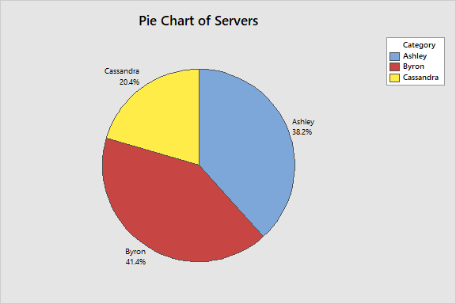
b. What percent of the tables during this five-day period were served by Cassandra? Remember, answer in a complete sentence.
20.4% of the tables were served by Cassandra during this five-day period.
c. Over the course of the five-day period, which server served the most tables? Remember, answer in a complete sentence.
Byron served 41.4% of the tables which is the most tables served in comparison of the servers.
2. (15 points) Open the Restaurant_Tips data file. You will create a bar chart and a table for a variable and answer questions related to the distribution of the variable.
a. Generate a bar chart and a table (Tally in Minitab) to display the distribution of the Day variable. This variable indicates the day on which the table was served at the restaurant. Paste the bar chart and the table into the document you upload for this assignment. The bar chart should have a proper title and labels and should include counts, but not percentages. The table (Tally) should include counts AND percentages.
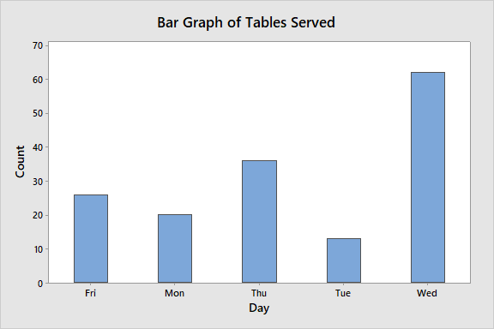
Tally
Day | Count | Percent
Fri | 26 | 16.56
Mon | 20 | 12.74
Thu | 36 | 22.93
Tue | 13 | 8.28
Wed | 62 | 39.49
N= | 157

b. On which day during this five-day period were the fewest number of tables served? Remember, answer in a complete sentence.
Tuesday during the five-period served the lowest number of tables which is a count of 13 (8.28%).
c. How many tables were served in the last 2 days of this five-day period (on Thursday or on Friday)? Remember, answer in a complete sentence
There was a 36 count (22.93%) of tables served Thursday and the other day had a 26 count (16.56%) of tables served on Friday.

